MICROPROCESSORS AND
MICROCONTROLLERS
E.Kavya
192424365

EXPERIMENTS 1-6

1. Arithmetic Operations in 8085 Microprocessors
a. 8-BIT ADDITION WITH CARRY USING DIRECT ADDRESSING

OUTPUT:

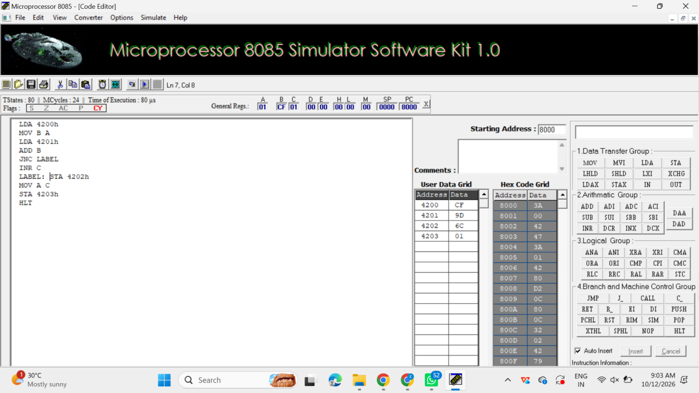

b. 8-BIT ADDITION USING INDIRECT ADDRESSING
OUTPUT: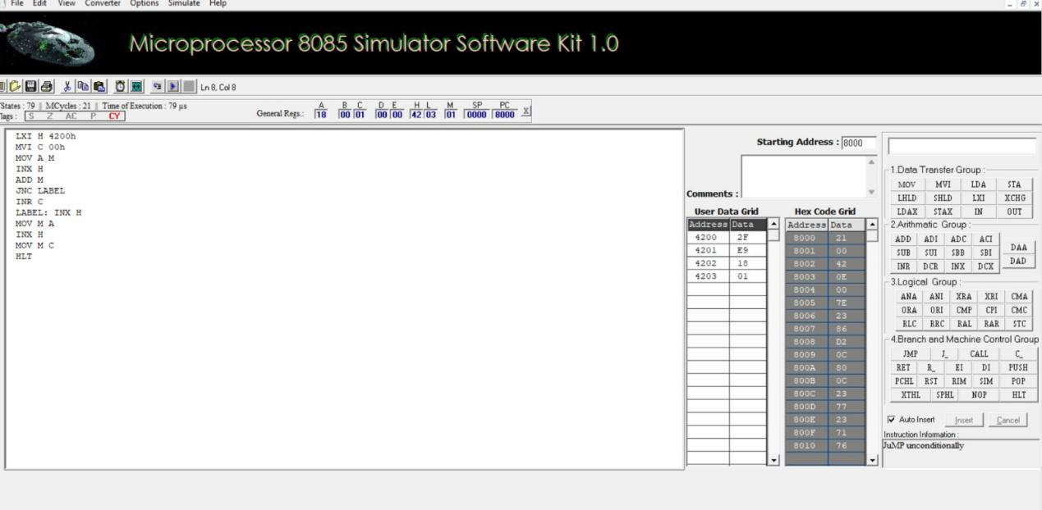

c. 8-BIT SUBTRACTION WITHOUT BORROW
OUTPUT:

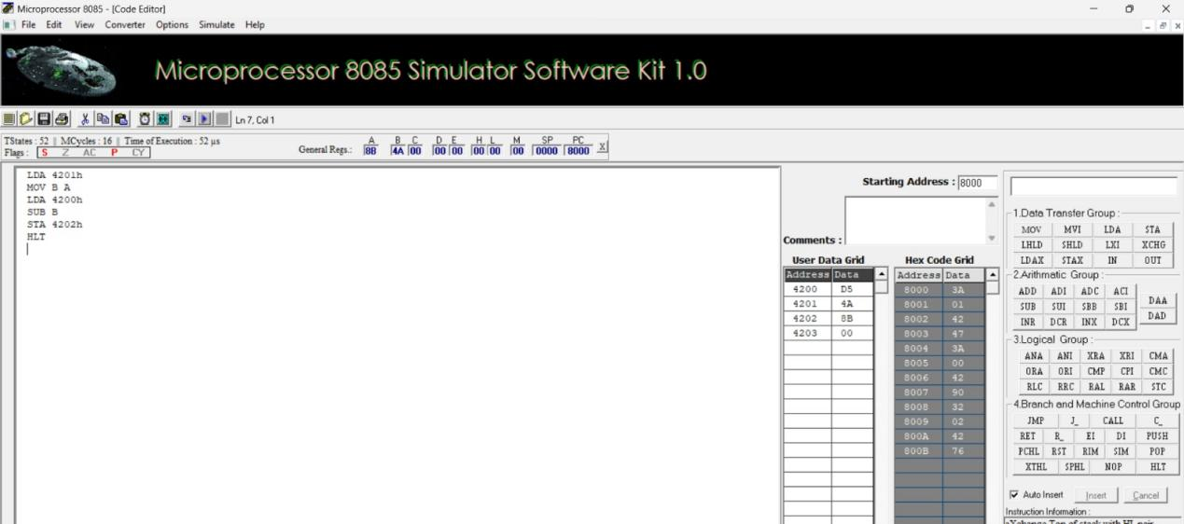

d. 8-BIT SUBTRACTION WITH BORROW USING DIRECT ADDRESSING
OUTPUT:

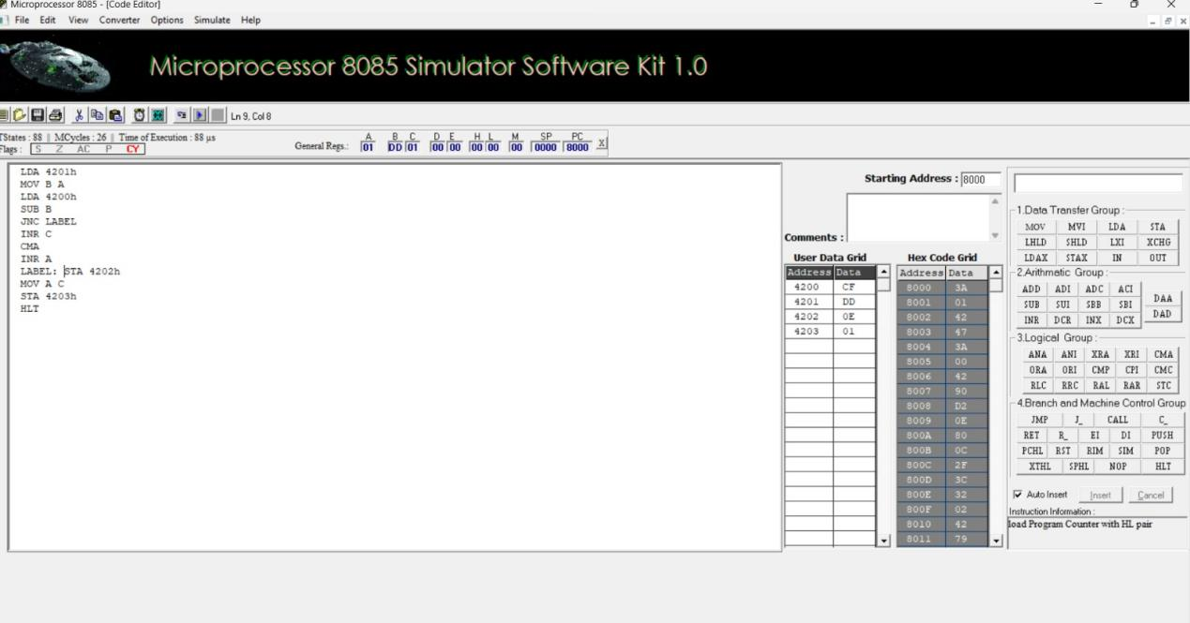
e. 8-BIT MULTIPLICATION OPERATIONS USING 8085 MICROPROCESSOR

OUTPUT:
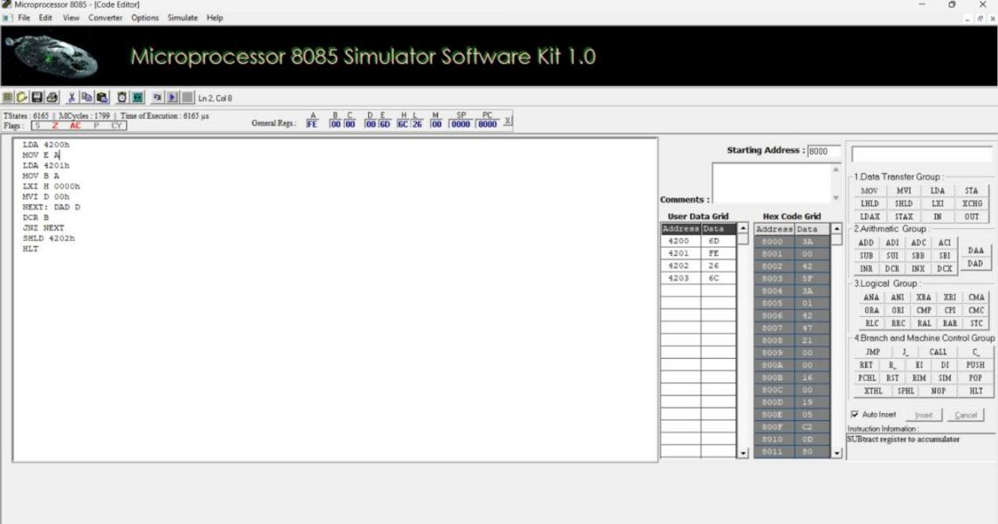

f. 8-BIT DIVISION OPERATIONS USING 8085
MICROPROCESSOR

OUTPUT:

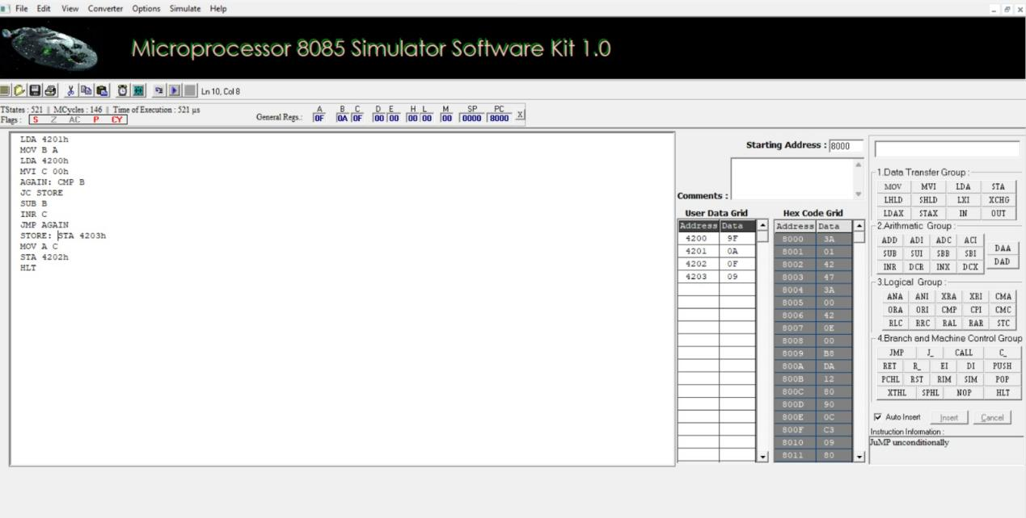

2a.SORT AN ARRAY OF DATA IN ASCENDING ORDER

OUTPUT:

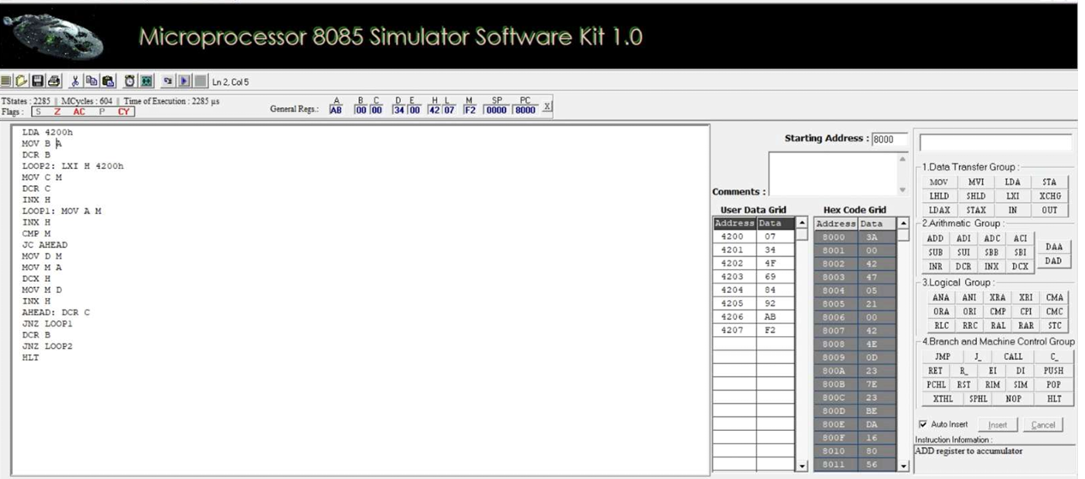

2b. SORT AN ARRAY OF DATA IN DESCENDING ORDER

OUTPUT:

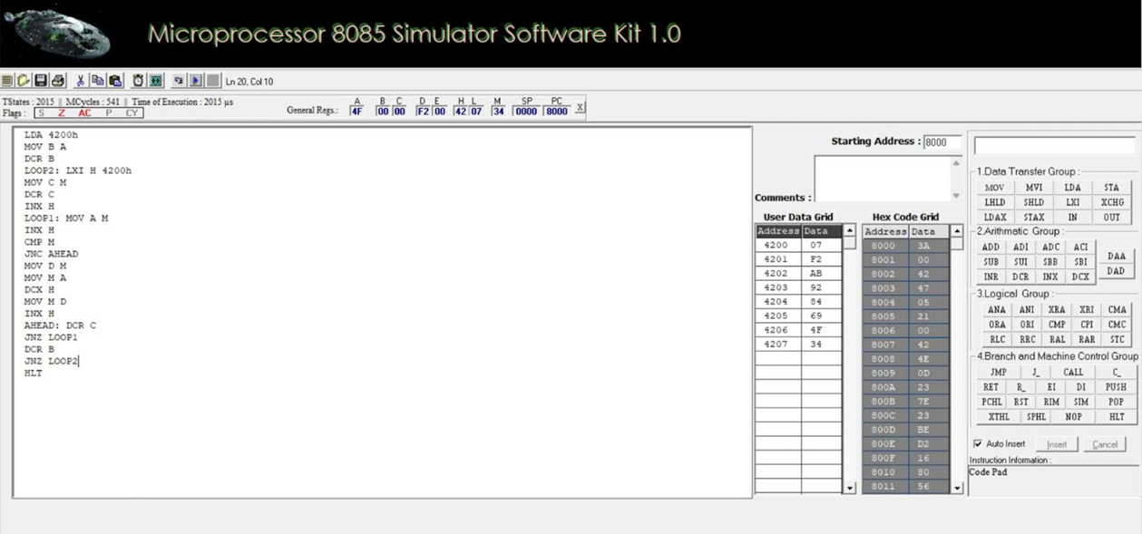

3. ASCII CODE TO HEX CODE CONVERSION

OUTPUT:

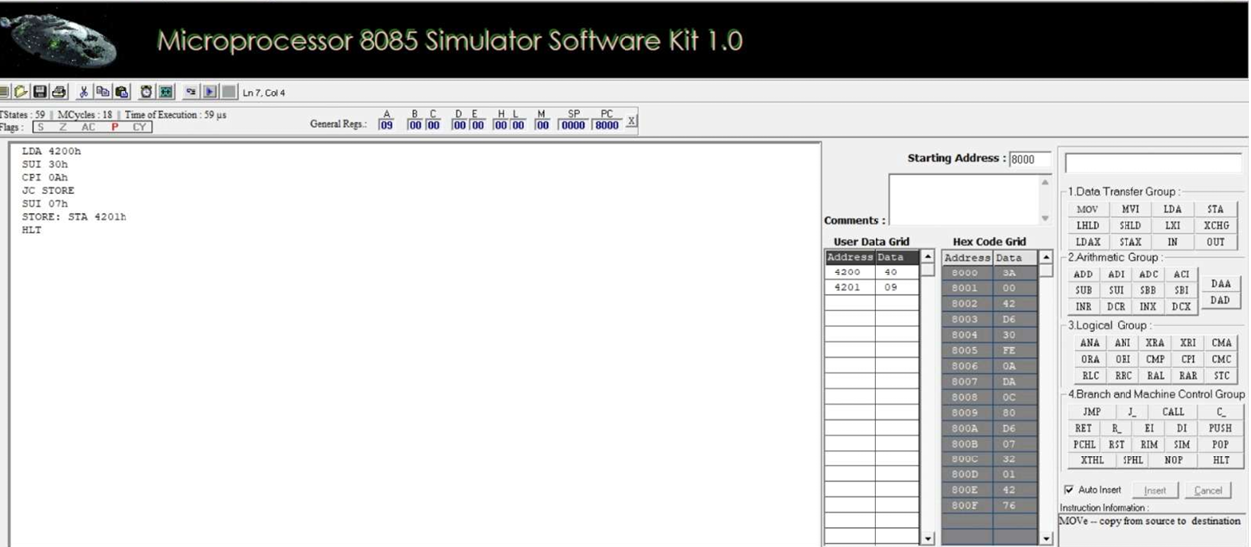

4. TRANSFERRING A BLOCK OF DATA BETWEEN MEMORY LOCATIONS AIM:

OUTPUT:

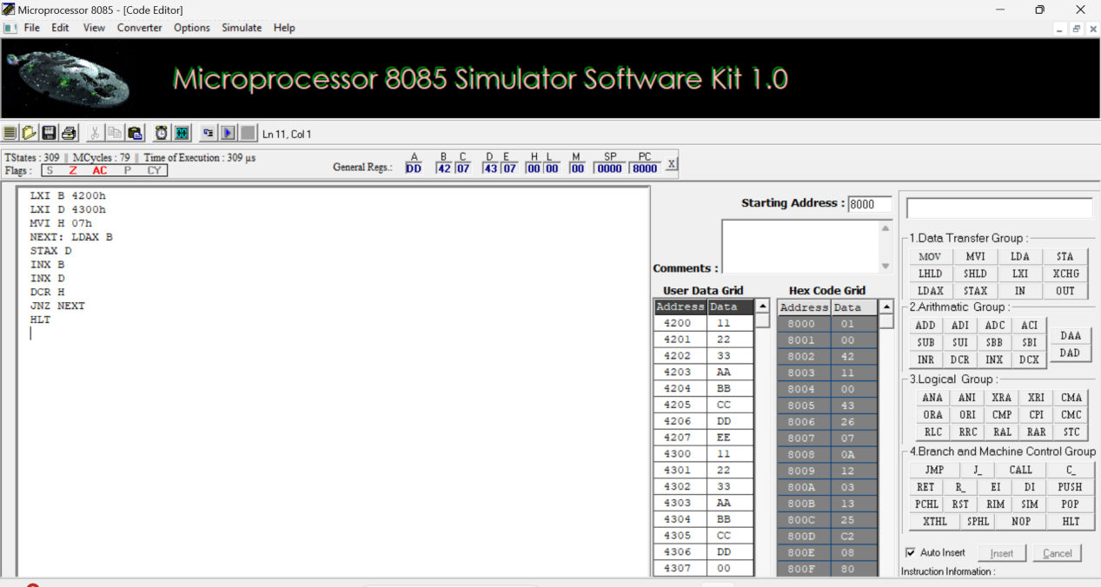
5a. MASKING AND SETTING OF LOWER NIBBLES ON GIVEN DATA

OUTPUT:

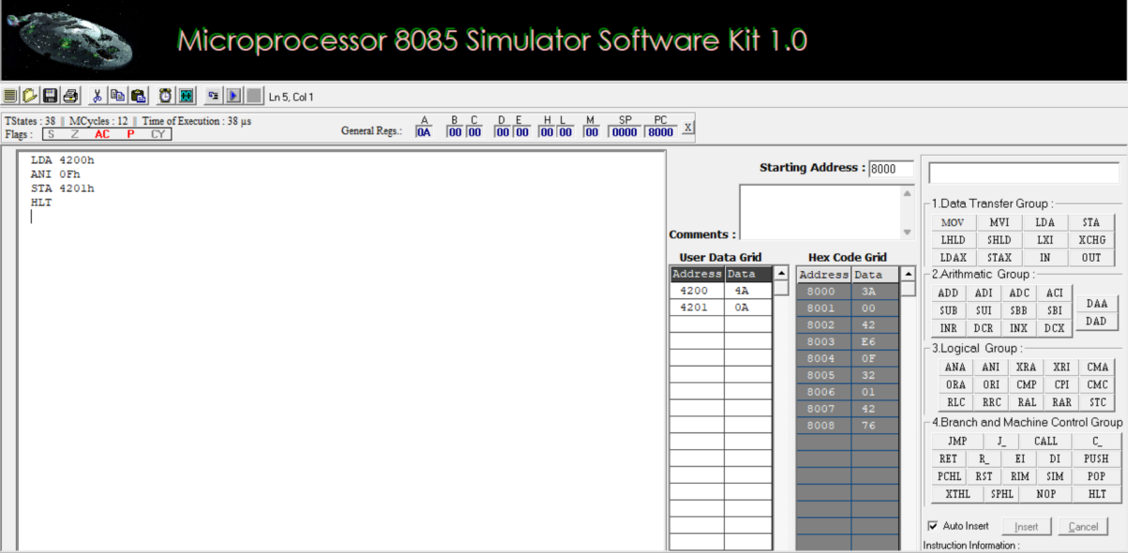

5b.ONE’S AND TWO’S COMPLEMENT
OUTPUT:

